**COURSEWORK – E-COMMERCE SITE**

**By: Ming Yao**

Contents

Analysis 4

Project Introduction 4

Identifying Problem 4

Project Definition 4

Justification of how the problem can be solved by computational methods 5

Thinking Abstractly 5

Thinking Ahead 5

Thinking Procedurally 6

Thinking Concurrently 7

Thinking Logically 8

Stakeholders 9

Internal Stakeholders 9

External Stakeholder 11

Summary of interviews 13

Problem Research and Similar Competitors 14

Similar Solution 1 (buying product): Amazon 14

Similar Solution 2 (buying product): Etsy 17

Similar solution 3 (buying product): John Lewis 20

Conclusion from similar products 23

Similar Solution 1 (selling products): eBay 24

Similar Solution 2 (selling products): Etsy 29

Conclusion from Similar Products (selling products): 33

Solution proposal 34

Features of Solution 34

Limitations of Solution 35

Hardware and Software Requirements 36

Computational thinking 37

Problem recognition 37

Elimination of error 37

Pipelining 37

Success Criteria 39

My Success Criteria 39

OCR success criteria 40

Design of Solution 41

Entity-relationship diagram 41

Justification for Tables 41

Top Down Design 42

Justification for top down chart 42

Tables 43

Users 43

Products 44

Basket 44

Basket Content 45

Draft Page Designs 46

Colour themes of website: 46

Usability Features: 46

Testing Data 47

Iterative Development Test Data 47

Customer Input data 47

Admin Default Data 48

Admin Input Test Data 48

Product Default Data 49

Generic Test Data 49

Checkout Page Data 50

Post Development Test data 51

Detailed Page Design 51

Home page design 51

Navigation bar features 52

Sign In / Up Page 57

Products page 59

Individual products page 61

Development 63

Setting up database 63

Connecting database 63

Creating Tables 64

Home Page 67

Users Home Page 67

Favourites Page 77

Notifications Page 77

Profile Page 77

Cart page 80

Users category page 83

Product Page 85

Sign in Page 91

Sign Up 94

Log Out 96

Admin pages 97

Main page 97

Security 98

Adding products 100

# Analysis

This section will entail the analysis of the problem at hand, describing the process of my solution, and finding what features are requires or wanted by the stakeholders, as well as satisfying what they expect from this solution.

## Project Introduction

### Identifying Problem

Previously, my sister and mother had made home-made products, such as crochet animals, knitting and homemade soft toys, who then distributed it to family, relatives and family friends. After becoming more of a hobby, they decided to start selling to people nearby, starting with our neighbourhood. Having seen them spend their time producing these products, and helping transport and deliver these items, I have observed that the process of physically spreading awareness and having a system to log who has bought which item became hard and confusing. The ordering system for these homemade products was inefficient and not worked on.

### Project Definition

For my project, I am planning to make a family-friendly ordering system for homemade products made by family members ; an ordering system similar to Lazada, Amazon, or Shopee, where you can view products and buy them. I plan to create a user interface which lets them view products through a filter (category based: types of product, price range, alphabetically), and add them to a specific cart. Additionally, users will be able to make an account and log in and log out so that their data is saved (address, contact details, etc).

Some pictures of the product that will be used:



## Justification of how the problem can be solved by computational methods

### Thinking Abstractly

Being web-based provides a solution of the customers that want a specialised, home-made crochet as it solves the problem of physically calling up my mother or sister in order to place an order. This website creates a process where users are able to search, sort and filter through the items available, and finally read through the details about a specific item (price, name, materials, etc) before purchasing and placing an order on their desired product. On the main page of the website, only key details will be displayed so that customers are able to view a wide variety of items at once, and will be able to read into depth of interested items.

On the admin side of this project, I create a solution for my mother and sister so that they wont need to receive countless phone calls and messages. This website will have an admin platform so that only admins are allowed to view orders that has been places as well as view any reviews made by previous customers.

### Thinking Ahead

Inputs:

I will need customer details (Full name, Address for delivery, email address, phone number, payment details such as a credit card, and a password for the account). These details will be used for the registration of an account and be used for the deliver and payment process. I will also need an input from the admins for new items being sold (a description of the item and its name, and multiple pictures of that item)

Output:

The outputs of my website will include the total cost of the items that the user has added to cart and wants to purchase, and a digital receipt which allows them to view the order that they have made (sent to email as well as on the screen that they were shopping on)

Caching:

Caching could be used in several components of my website such as the items produced as well as the CSS of my website which details the appearance of the website. It is because I will be unable to frequently update these components, so that caching them can be beneficial in terms of reducing time taken to load up the webpage

Other Details:

I will most likely reuse components of the website across all webpages, such as a general CSS style sheet so that multiple pages of the website have the same style (product page and main page). This helps each page of my website follow the same or similar colour scheme and architecture to maintain a sense of corporate image.

### Thinking Procedurally

To simplify the task that will need to be achieved, I am able to decompose specific problems into smaller steps to handle. For example:

Adding to basket:

* The customer should be able to press add to cart from a product page
  + If customer wishes to read details of a product, there should be another button to add to cart there
* Customer should be able to then go back to the online menu of products
* The customer should then be able to click on the shopping cart icon to view all their products in cart

Placing an order:

* Customer should be able to view all orders in their basket
  + If customer wishes to buy a single item, they should be allowed to press buy item from the products page itself
* Customer should be able to then login
* Customer must enter their full passcode and match the passcode stored in the system
* Customer should then be able to press a checkout button which leads them into the payment system they wish to use

### Thinking Concurrently

Specific aspects of my website will need to be able to be performed simultaneously on multiple different users interface, and these multiple interfaces shouldn’t be slowed or hindered by one another

* Allows multiple customers to order and buy a product at the same time
* Allows the admin page / supervision monitor to be updates immediately as soon as an order has been placed
* Allows admin page to view who is currently signed in or when a new account has been made

### Thinking Logically

Branching and pipelining will be needed for certain aspects of my solution, and to allow the website to function fast. For example, if a customer has finished viewing items they should be brought to a checkout page. If they haven’t finished, they should be looped back into viewing items.



## Stakeholders

There are three main stakeholders for my website that I will need to consider: my mother, sister, and the general public. Two of which are the origins of the website, and I will use a few friends who is a regular e-commerce as an example of the general public. I will conduct interviews for each of them in order to get feedback on how to shape my website in order for it to be desired by other customers.

### Internal Stakeholders

For my internal stakeholders (the ones who are involved in the creation of my website), I asked them general questions regarding the features and desires for the website. I will need to have a full grasp of the idea of website they would like to be built before starting the process. I am hoping for them to be able to add items on their own without my help.

Main management will be my mom, with my sister helping on holidays. She would like an easy accessible and functional website in order to add items easily and be able to view who has bought which item. I will need to consider efficiency as my mother may be really busy and may be time consuming to switch between tabs

It will be useful for both my parents and sister, as they don’t really have a system yet allowing them to successfully and efficiently sell the items that they are able to make. With this website, they are able to sell these items in a website of their choice. So these questions allow me to envision the type of website they would like to have

General questions:

* Would you like to constantly add new items to the website weekly or monthly?
* What crowd of customers are you hoping to look for?
* How do you wish for the website to differ from current ongoing websites, such as amazon or Lazada?
* Have you previously missed orders by other people (forgot to produce a specific product for someone else)?
* Which webpage needs the most attention?
  + Assuming it’s the homepage, what information and detail would you like to add to the homepage?
* Have you had any negative experiences with selling your product?
  + Can this website help solve that problem?
* What would you like customers to be able to do?
  + Will there be promotions and pop up adds?
* What functionalities will management need?

#### My mother:

* Yes I would like to add new items on a weekly basis, and would like the website to show recently added items on the top of the page
* Website needs to be easy, and simple to look through or navigate
  + A website that:
    - Loads quickly
    - Drop down buttons and categories need to be divided clearly
    - Fonts need to be big and easily read
    - Have a very accessible “help” button for customer usability
  + Accurate and sufficient information on the products itself
  + A platform for customer reviews and responses
    - A method to reply to consumer feedback
* The homepage or product page will need the most attention as it is where the consumers buy from
  + Highlight sales and promotion items or package promotions
  + Pop-up new items and promotional ads
  + Reminder email on new product and sales to consumers that aren’t active on the website
  + Give discounts to recurring customers
* Responsibilities of management:
  + Be able to reply quickly to customer questions
  + Check on website functionality
  + Update items on a weekly basis
  + Usable online payment systems

#### My sister:

* Add new items monthly with an easy access to the recently added items so that admin users can edit as we please
* Looking towards little children and possibly adults
  + In order to catch their attention, I would like a website that is aesthetically pleasing and eye catching or adults to shop on
  + also very simple so that young kids can understand what is being posted
* More colourful and friendlier looked than Lazada or amazon
* Homepage and the view page for all the products being published needs the most attention
  + This page will be the page which either persuades people to join or turn people off
  + Colourful
  + easy to use
  + the buttons for categories are easy to spot by other users
* Customers should be able to easily view products and add products to their cart or Wishlist
* If you have finished the website, I would like admins to be able to put up promotions for an holidays
  + Needs to be very visible by others so that they don’t have to search for it when looking for others
  + Not too badgering and big that customers cant scroll through the pages

### External Stakeholder

For my external stakeholders (the public), I asked for the drawbacks and downsides of currently running e-commerce sites, as well as what they look for when they shop for products (what makes an e-commerce site easy and accessible). Users should be able to comfortably browse the website, and create their own personal account where they can store information. I will also ask my aunty who is a frequent user of shopping online, and someone who helps represent other brands by spreading their awareness on social media.

My external stakeholders will be using this website in order to easily locate the items that my mom and sister are going to sell, allowing them to inspect it and read through the detail of it.

General questions:

* What do you look for in a website that sells home-made products?
  + Do aesthetics of a website affect your experience
* What problems do you face with current websites/applications that allow you to shop for products?
* How can an e-commerce website meet your needs to shop for home-made products, such as knitting and crochet?
* Are there any specific features that will prompt you to use a certain brand over another?

#### My friend (angel):

* A website that is easy to navigate, I like a minimalist design, so colours are not really clashing with each other, product details, don’t make the font too small and not too much texts (more pictures)
* If I don’t sign up/login in the webpage, they make me login after adding to the cart, then when I login I lose all the items in my cart.
  + It is hard to search for products that I want (names are very complicated)
  + Not enough categories to pick from for items that I desire
* A website that shows pictures of the product and of the different colours. Including the sizing too (cm/m) as pictures may be very deceiving.
* Websites with no ads, I don’t like websites that when they put suggested items after adding something to cart, it just checks the suggested item and I have to untick it

#### My friend (Grace):

* A website that is very sleek and minimalistic so that it is easier on the user’s eyes and makes it look very professional and it helps to make the information you want to get across clearer to the user’s shopping for the product
* When you put a specific item in search bar, a lot of results come out which makes it hard to search for a specific item that I design
* A website that shows a variety of categories so that you can find the product you want without having to search for the names
* When a website has a wish list (a section where you can favourite and save the items you like without having to add it to a specific basket / cart)

#### My aunty (Jessie):

* A website with very clean pictures (with a clear price / less text about it)
  + There will be text when you click on the picture such as a description
  + Product detail only when I have clicked on the product itself so that the homepage is very minimalistic and easy to read
  + A website that is easy to navigate in order to please
  + For homemade products, a video could be helpful
* I hate it when I have to sign up in order to checkout
  + If I just want to checkout without putting personal details, I want to be able to checkout straight towards the payment gateway so that it is easy to buy products
  + I would like it if I can sign in as a member for any discounted items and promotions that add up in my account, however if it is just to buy a simple item I would prefer if I can just proceed to checkout where I have to insert my bank details
* I don’t like when a website has too many steps
  + When I have to continuously click numerous buttons to checkout and it gets too clicky
  + You need a website to look slick and very easy to checkout
    - Big buttons for adding to cart
    - Price on every picture
* I would choose a certain website over another if it is very fast and easy to access
  + When a website has minimal buttons but the key details are shown clearly
    - Details such as delivery date, etc

### Summary of interviews

Features that will be added:

* Homepage
  + Eye catching colours which is not too bright and dark
    - Must be aesthetically pleasing in order to convince users to use this website
  + Loads of pictures with minimal detail possible
    - Picture + price + name
  + Certain videos or sliding pictures of the production itself so that it is very persuasive
  + Very little buttons
    - Only navigation bar, and certain promotion buttons
* Other sections of the website
  + Make the shopping cart page very minimalistic and only asks you to sign in when necessary, if not it will just ask for a payment page + address page
  + Very little description on product page until you click in on the specific product itself

Features to exclude:

* Don’t make the website have too many buttons
* Make sure you don’t jumble up the search bar
* Make sure the login/sign up page is completely separate to the shopping cart page and it doesn’t affect one another.

Overall, these interviews allowed me to view the type of website that should be made which includes the layout, and presentation of it on a consumer viewpoint. But also about the functionality of it and how well it needs to work in order to satisfy consumer demands and to attract customers.

## Problem Research and Similar Competitors

The main problem of this website is the similarities between websites already running. Furthermore, the website will need a system where management can easily view all the data from the person who has bought a product all at once (address, name, product and custom features)

### Similar Solution 1 (buying product): Amazon







Features identified –

* Homepage which shows you the latest deals, promotions, trending and most popular items
* Top navigation bar which does not change when moving between web pages
* Categories stored on top bar as well as side bar
* Sign up/Log in page
  + Connected to the shopping where you have to login whenever you wish to checkout
* A lot of images in order to show the pictures of the product itself as well as its name + discount

Drawbacks of Amazon –

* looks very messy and complicated
* a lot of different types of products linked to amazon, so there is a lot of categories that may get confusing
* may be hard to know where to start



**A footer to show different sections of the website, but it is in a very messy format**

Simple About Us section at the footer of the website

### Similar Solution 2 (buying product): Etsy

Etsy by far is my favourite website so far, as it has minimalistic designs and very eye catching colours, which I will need to implement in my designs





This showcases an example of how a product may be displayed on its webpage – small description is very important





Features identified–

* minimalist homepage with very little buttons for categories and product ideas
* top navigation bar which doesn’t change
  + very minimalist as there’s not too much detail but all the important information is displayed
* sign in/ log in page
* able to clearly change language of the website
* when in a specific category, your able to easily change category without having to go back to homepage

Drawbacks of Etsy –

* doesn’t make you sign in or log in before viewing shopping cart

Etsy offers this small description on what they are which shows how they work



Has a section to show the items you favourite or like so that you can save specific items that you like, and alter your algorithm so items of your liking will pop up on the home page

### Similar solution 3 (buying product): John Lewis





This website is very good at showcasing the categories they have for each product as it is very clear the subcategories and even further sub categories so that people can easily find the product they want



Features identified –

* Homepage which shows you the latest deals, promotions, trending and most popular items
* Top navigation bar which does not change when moving between web pages
* Categories stored on top navigation bar so it is easy to find
* Sign up/Log in page
  + Connected to the shopping where you have to login whenever you wish to checkout
* A lot of images in order to show the pictures of the product itself as well as its name + discount
* Shows deals up to a specific discount so your able to easily see how much discounts a specific item have

Drawbacks of John Lewis –

* Very messy navigation bar so it may be confusing on where to search for specific products
* Looks confusing and unsure of where to start to search for specific products



Brief about us description but worst than amazon since they leave it in a big chunk of text

Very entertaining pop up page to show the sections and bring you back to the homepage

### Conclusion from similar products

These here websites serves its purpose to publish products and purchase them in a time efficient manner, however I feel like for majority of these websites, a significant improvement could be the aesthetics of the website: minimalistic and eye catching. I think for john Lewis and amazon, the homepage could be more condensed so that the viewers are more likely to stay on that specific website. Additionally, I believe improvements could be made through the shopping carts page by making It less confusing with fewer problems that occur, as it was a problem throughout both my interviews and when researching these websites.

Some ideas to implement in my website:

* Minimalistic homepage with very stylistic buttons like Etsy’s homepage
* A very generalised theme across all my webpages even when it goes into the products
* A form of recommended products and items that viewers may like
* An easy and accessible login / sign up / carts page (pop up form)



More of an additional part to my project – this showcases the promotions and the discounts for certain products and displays them based on popularity as well as based on what you may like due to computational algorithm

### Similar Solution 1 (selling products): eBay



The steps that eBay puts you through to sell an item ^

Step 1:



It asks you to enter the item name, and makes sure that its very precise





Asks for the quality of the item your selling to put in as description of item

Step 2:

This part asks you to enter the exact details of the item ensuring that it is full of information and has enough data to talk about inside the products page itself

Asks you to add every little detail to add onto the website, ensuring that users know what It is





Gives you a section to write any brief description about the product



Gives you an option to donate money to charity and how you want others to pay for it

### Similar Solution 2 (selling products): Etsy

Step 1:

They first ask you where your based and where you want to start shop in order to promote your shop based on your country so people can find you



Step 2:

It then asks you for a shop name for people to recognise you



Step 3:

It then asks you for detail of products. All of these sections below allow Etsy to create a webpage for your product and will show all of it.





Just a basic description of the product itself to write up about it

Instead of just adding photos it asks for you to add a video in order to show the item clearly













The next few steps contain a payment system which allows the admins to get paid by the users specifically, in which case I will only include if my project gets far enough.

### Conclusion from Similar Products (selling products):

Features to include inside website:

* Initially the adding of items to sell on my website will only be open for admin users (my mother and sister) so that they are the only ones allowed to sell items
* This will be done through an admin portal in a separate admin webpage inside my website
* Features to include:
  + Ensure to create a large listing of description for product:
    - Picture
    - Title
    - Category
    - Description
    - Price
    - Quality of product
    - Video (optional)
    - Payment methods
    - Tags
    - Material
    - Quantity
    - type
  + Create a separate section for delivery address
    - Address from where (calculate how long it will take to deliver)
    - Production time
    - Methods of delivery (pickup or deliver to house)
  + Create a separate section for payment
    - Different types of payment that admins will have
    - Most likely card and online transfer (touch and go (Malaysian method of online transfer)

## Solution proposal

### Features of Solution

#### Customer Features

* Customers will be able to add items to cart with or without an account and possibly be able to buy items without an account
  + Will need to just key in delivery address and name
* Customers will be able to leave reviews on the websites either for a specific product or a more general comment about the whole website and service as a whole
* Customers will be able to search for their desired items without having to search for the whole exact name
  + If they search for a batman watch, a few variety of batman watches will appear
* Customers can cancel their order after pressing checkout so that they can recheck their order before paying
* Each customer can access the website at the same time
* Customers will be able to see and easily access the wide variety of products ranging from each category
* There will be a page where you can add favourited items to a list and it will save it for whenever you re-log in

#### Admin Features

* Admins will be able to login via an admin portal with an admins account. This will bring them to a separate system where they can manage all the orders being places and find out which order is meant to be delivered to where
* Admins will be able to add new products to the menu when desired
  + They will have to key in details such as: product name, product description, product price, picture of product, etc
* Admins will be able to remove products if they no longer produce that specific product
* A weekly income will be calculated automatically and admins will be able to see how much has been made
  + They will also be allowed to add in any cost of production to find total profits after deducting the cost of production
* There will be a webpage inside admins portal where it gives an analysis of the website itself
  + This will showcase busiest times and days when people shop, most bought items, most viewed items, and the amount of time customers spend on the website

#### Producer Features

* There will be a list of customer orders written down in a list which will be viewable by my mother and sister in an orderly manner
  + These customer orders will be written in a format so that they can see
    - Number of orders places
    - The colour of the item
    - Specific demands and requirements
    - Any other comments about the product
  + This will be displayed in a way so that each sale will be displayed in a separate section to make it easily read and not confuse any orders
* There will be a checkbox for every product being made, so that after production is completed, their able to check it off to show that it has finished being produced
  + This allows both admins and customers to know where each product is in the stage of production and delivery and creates a very easy flow of movement

#### Delivery Features

(if I’m able to implement this after finishing the website itself – more of an additional part to my coursework)

* There will be a list displayed of each order (order number + what is being produced) and the customers address and name
  + This will be displayed in a tick box list so that after each delivery, they can check off the product and show that it was confirmed delivered to the place
  + This allows both my admins and customers to create a very orderly form of check and deliver so that we know where each product is in our process of production and delivery

### Limitations of Solution

Limitations of my solution due to the complexity of various sections of the website:

* The payment system may be very hard to achieve as it will ask for card details, etc and will need to be accessed via a proper bank
  + I will implement a proper system at a later stage of my website
* I will try have a minimalistic navigation bar but due to the amount of information that is on my product pages, etc I will have a hard time finding the best balance between minimalistic and showing information

## Hardware and Software Requirements

Since my project is an e-commerce website, the main software required for the library database will be provided by Award Space, which hosts a free web server where I can store all the webpages (SQL server). This will be used for both development and deployment, and is a crucial because it hosts a library for me to collect and store all my data in one specific location. Additional hardware which are required for the construction of my project are a mouse, keyboard, monitor, external hard drive, at least 4GB RAM to run my project smoothly on my computer, and a touchscreen

The code will be developed using a variety of software, on Windows which is provided by my school. Some of which are XAMPP, github, Visual Studio Code and any other programming software incase I will need to test codes or debug codes. These software programmes allow me to code and write up the websites to host an e-commerce site for my mother and sister. The programming languages I will be using here are mainly php, and html and css for both presentation and information of the website.

I upload the code to github regularly to make sure I always have a copy in case my laptop or any external problems occur. I will not be coding on any other platform, but it is nice to have all my code stored in one place, and I can open it on any other computer to display the code.





## Computational thinking

This problem and project is well suited for a computational solution and logical thinking for the production of the web based algorithms. It is a web system that acts as a main buffer for production and e-commerce stage. In this project I will be using various computational methods in order to perform maximum efficiency and allow the users to load their website as fast as possible.

### Problem recognition

Computers are able to solve problems using sequential and logical steps. For my project, the biggest problem is the display of products which will be taken from data stored in the database. Along with this problem, each subsequent product will be needed to have a function added to it that will store it as an item potential being bought and being bought: it will need a function to add users data to an administrator’s table. This data viewed by administrators should be able easily accessible without needing to see the backend code. However, many of these codes can be reused and readapted between each sub web page and subsystem.

### Elimination of error

By using computational algorithms to store data, both by administrators and users on the website, we’re able to quicken the process and save time rewriting up all the reports. This also helps eliminate any human error, such as a misspelling of a specific address, name or postcode. As well as solving errors, computers can store a large amount of data without losing, confusing or mixing up the data, which may be invisible to a human eye. The recent AI technology allows us to find patterns when writing up algorithms to show where It can be shortened, as well as show where the patters and similarities between data is.

### Pipelining

Many subsystems in my web system relies on connecting with the SQL server, which there is a slight delay when request is sent and when a package with the requested information return. Since these systems rely on the web server for records or data, man JavaScript and php algorithms will be subjected to pipelining, where they have no choice but to wait for the response from the server before any other code can be ran.

I will be using pipelining for several problems such as my “add to cart” system. Where the subsystem can only calculate the total, total + tax, and all other payments after the algorithm has added an item to cart. The efficiency of pipelining will be used throughout all my subsystems.

Ultimately, may subsystem codes will rely on a sequential processing method, where one thing happens and another happens after that, because the nature of the program is not suitable for OOP.

Some examples of pipelining and sequential processing methods that Etsy had used and that I will implement into my website are:





When your still on the homepage and if you hover over the carts page, it shows you what items you have in cart and how much it is in total

Once at checkout it gives you various options to use in order to pay for the products as well as giving you a breakdown of each price

## Success Criteria

### My Success Criteria

#### Website (user design)

(presentations and design of the website to please users)

|  |  |  |
| --- | --- | --- |
| No. | Criteria | Justification |
| A1 | Home page should have an image carousel | Displays popular products to make users want to click on it and look through the website more |
| A2 | All web pages should have a common theme | Includes nav-bar, colour scheme and highlights so that it shows unity and it doesn’t put users off |
| A3 | Product display page should hold at least 15 products | Since it is a demo, it should have a minimum amount of products so that they can see what it looks like |
| A4 | Pages should not be cluttered with too many designs | This puts users off and makes them not want to shop there |
| A5 | Colour scheme should be coherent and connecting | Aesthetically pleasing which makes users want to use it |
| A6 | Single product should show all detail | Includes a fitting picture of item (carousel if possible), brief description, title, and price |
| A7 | Able to make an account | Users need to be able to make an account and edit it incase they want to change the detail |

#### Website (administrators management)

(coding and background of what admins can do)

|  |  |  |
| --- | --- | --- |
| No. | Criteria | Justification |
| B1 | Admins should be able to manually add items | Without editing the code of the website, admins should have a webpage that allows them to add detail which adds it automatically |
| B2 | Admins should be able to add other admins onto the system | If someone decides to help manage the website (add items, etc), the original admins should be able to add them onto the database without editing the code |
| B3 | Admins can edit and delete products | If they decide not to produce a product anymore, they should be able to edit and delete it |
| B4 | Should be able to automatically edit the carousel and promotion page | If a new item has become more popular, admins should be able to add this to a promotion page |

#### Database and Backend Processing

|  |  |  |
| --- | --- | --- |
| No. | Criteria | Justification |
| C1 | Password should be hashed | For the security and privacy of all the users, all passwords should be hashed |
| C2 | Password should be sent through the internet as a hash | Database code should just run a hash check with the stored password hash on the database |
| C3 | Ensure users can’t view admins page | Should only allow users with an admin password or privilege to view the page. Before viewing, they will need to be put to a login page |
| C4 | Stored information should be able to be changed | This is due to the Data Protection Act o 2018 regulations |
| C5 | When adding products to profile, a session should be started | Ensure that data of that person can be stored into the table without mixing up their userID and data with others |
| C6 | Two users on the website should be handled separately | There will be a chance two people are using it simultaneously and the website shouldn’t confuse them |
| C7 | Admins should be able to edit, add or remove any data | There should be a webpage for admins to change the content of the pages without having to alter the code of the pages, as mistakes could easily be made, and it is more efficient |

### OCR success criteria

I will constantly look at the OCR exam board success criteria and tick off the sections that I have completed as I go along to ensure I aim for the top and maximum marks possible.

![Programming project (Component 03 or 04) marking criteria 
AO 2.2 Analysis (maximum 10 marks) 
marks 
The candidate Will have: 
• Identified some features 
that make the problem 
solvable by computational 
methods. 
• Identified suitable 
stakeholders for the 
project and described 
them and some of their 
requirements. 
• Identified some appropriate 
features to incorporate into 
their solution. 
• Identified some features 
of the proposed 
computational solution. 
• Identified some limitations 
of the proposed solution. 
• Identified some 
requirements for the 
solution. 
• Identified some success 
criteria for the proposed 
solution. 
3—5 marks 
• Described the features that 
make the problem solvable by 
computational methods. 
• Identified suitable 
stakeholders for the project 
and described how they will 
make use of the proposed 
solution. 
• Researched the problem 
looking at existing solutions to 
similar problems identifying 
some appropriate features 
to incorporate into their 
solution. 
• Identified the essential 
features Of the proposed 
computational solution. 
• Identified and described some 
limitations of the proposed 
solution. 
• Identified most requirements 
for the solution. 
• Identified some measurable 
success criteria for the 
proposed solution. 
— 70 marks 
marks 
• Described the features that make the 
problem solvable by computational 
methods and why it is amenable to a 
computational approach. 
• Identified suitable stakeholders for the 
project and described them and how 
they will make use of the proposed 
solution and why it is appropriate to 
their needs. 
• Researched the problem in depth 
looking at existing solutions to similar 
problems identifying and describing 
suitable approaches based on this 
research. 
• Identified and described the 
essential features of the proposed 
computational solution. 
• Identified and explained any limitations 
of the proposed solution. 
• Specified the requirements for the 
solution including (as appropriate) any 
hardware and software requirements. 
• Identified measurable success criteria 
for the proposed solution. 
9—10 marks 
• Described and justified the features that make 
the problem solvable by computational methods, 
explaining why it is amenable to a computational 
approach. 
• Identified suitable stakeholders for the project 
and described them explaining how they will 
make use of the proposed solution and why it is 
appropriate to their needs. 
• Researched the problem in depth looking at 
existing solutions to similar problems, identifying 
and justifying suitable approaches based on this 
research. 
• Identified the essential features of the proposed 
computational solution explaining these choices. 
• Identified and explained with justification any 
limitations of the proposed solution. 
• Specified and justified the requirements for the 
solution including (as appropriate) any hardware 
and software requirements. 
• Identified and justified measurable success 
criteria for the proposed solution. 
O marks = no response or no response worthy of credit. ]()

# Design of Solution

## Entity-relationship diagram

This diagram describes the different tables I will use and how it is linked to one another for me to store data and to output onto my website for both admins and customers. For my website to successfully run, I will need to have multiple tables to store the data of multiple items.

### Justification for Tables

The table “users” will store all the data of 2 different types of users: admins (management) and customers (e-commerce). This will then allow the website to log in your account when using the website.

The table “Products” will store all the data about the item or product being sold (crochet, and homemade items). This includes the name, price, and other information and descriptions about the product itself. So that when you view the website, all this information will be neatly displayed in an aesthetically pleasing format.

The table “Basket” stores the entire order of the customer itself. This includes the specific user who has bought the products, the date he bought it and expected delivery date so that it can be displayed to the users who wish to track their shipment. An extra section will be included to show whether the order has been delivered and paid.

The table “basket content” stores the products and items itself to show what that person has bought and to list it out for management to view and produce accordingly.



## Top Down Design



### Justification for top down chart

For my homepage to be user-friendly and easily accessible, there will be a top navigation bar. This will detail all the different products (categories) and certain aspects of a common e-commerce website (profile, cart, search bar). There will also be a clear main homepage button to easily link back to the central page. By using the same navigation bar across all webpages, customers will easily adapt and learn how to use the website.

As a common e-commerce website, the sign up / sign in page will allow customers to create their own personal profile which includes details: name, address, email, password, postcode, phone number and age. The profile webpage will allow customers to edit these specific details if needed to.

On the administrator’s side of the webpage, there will be two sections to this in order to manage the site as well as access all the orders being places and produce it accordingly. When managing the website, they are able to view everyone signed up in the website and edit their information if needed. Their also able to add and edit products when they want to create new products or change the description or price of a particular product.

## Tables

### Users

|  |  |  |  |  |
| --- | --- | --- | --- | --- |
| Field Names | Data Type | Validation | Typical Data | Justification |
| UserID | INT (6)  Primary Key | Must be exactly 6 digits (auto-generated) | 123456 | Easily identifiable so that the user’s data can be easily extracted |
| Email | VARCHAR (300) | Used up for login page | macmingyao@gmail.com | Can store all lengths of email addresses |
| Password | VARCHAR(300) | Required (customer profile) | *&bnfsk973q( | Allows users to create long passwords (long and has a range of special characters) |
| Forename | VARCHAR(30) | Required (customer profile) | Ming Yao | 30 characters to allow names to be easily stored |
| Surname | VARCHAR(20) | Required (customer profile) | Mac | 20 characters to allow surnames to be easily stored |
| Address | VARCHAR(300) | Required (customer profile) | Crosby house, Milton road, Oundle, Peterborough, England | Allows users to add in their entire address as some may be longer than others |
| Postcode | VARCHAR(8) | Required (customer profile) | PE8 4ET | 8 characters as postcodes are usually a maximum of 8 digits long |
| PhoneNo | INT(11) | Required (Length must be 11 digits long) | 01234567891 | Majority of phone numbers (international) are 11 digits long and can be stored |
| Type | TINYINT(1) | Required (proof for admin or customer) | 1 (admins) | Allows admins to validate if their admins |

### Products

|  |  |  |  |  |
| --- | --- | --- | --- | --- |
| Field Names | Data Type | Validation | Typical Data | Justification |
| ProductID | INT(6)  Primary Key | 6 random digits generated (auto-generated) | 012345 | Easily identifiable so that the user’s data can be easily extracted |
| ProductName | VARCHAR(100) | Required (customer profile) | Iphone 13 pro max casing | 100 characters maximum incase product name is long |
| Price | INT(10) | Required (customer profile) | 12.99 | Shows price of each product to 2 decimal place |
| Description | VARCHAR(300) | Required (customer profile) | Ghiweoagweg  Wegawegwe  Wege | 300 characters so description is not too long and impossible to store on screen |
| Category | VARCHAR(300) | Required (customer profile) | Casing | Category of product it is in order to easily sort on website |
| ItemImage | VARCHAR (100) | Required (customer profile) | Apple.jpeg | Show a picture or few pictures of a product |
| Quantity | INT(6) | Required (customer profile) | 4 | Amount of product available to purchase |

### Basket

|  |  |  |  |  |
| --- | --- | --- | --- | --- |
| Field Names | Data Type | Validation | Typical Data | Justification |
| OrderNo | INT(6)  Primary Key | 6 random digits generated (auto-generated) | 012345 | Easily identifiable so that the user’s data can be easily extracted |
| UserID | INT(6)  Foreign Key | Foreign key from users table | 123456 | Connected to a different table so ID will be same |
| Date_Bought | DATE(YYYY-MM-DD) | Required | 2024-11-29 | to show receipt and calculate delivery date |
| Delivery_Date | DATE (YYYY-MM-DD) | Required | 2024-12-12 | Date_Bought + 2 weeks maximum (sometimes 1 week) |
| Delivered | INT (1) | Between 1 and 0 | 0 | to show it is was delivered |
| Paid | INT(1) | Between 1 and 0 | 1 | to show if item has been paid for |

### Basket Content

|  |  |  |  |  |
| --- | --- | --- | --- | --- |
| Field Names | Data Type | Validation | Typical Data | Justification |
| OrderNo | INT(6)  Primary Key | 6 random digits generated (auto-generated) | 012345 | Easily identifiable so that the user’s data can be easily extracted |
| ProductID | INT(6)  Foreign Key | Foreign key from users table | 021345 | ID will show which products are in the order |
| Quantity | INT(2) | required | 5 | Show how many of 1 item has been ordered |

## Draft Page Designs



### Colour themes of website:

Draft colours for my website of different shades of blue (using some other [websites](https://designshack.net/articles/trends/best-website-color-schemes/) color scheme for inspiration):

* Dark blue = #00458B
* Light blue = #99DDFF
* Turqoise = #3FD2C7

### Usability Features:

* There will be a generic navigation bar at the top of every web page allowing the users to easily switch between web pages
  + Pressing the logo will bring users to the homepage
  + Categories list will have a dropdown list of different big categories of products
  + Search bar will let users find a specific product using AI to give suggestions
  + All other sub symbols on the right hand side will bring a different feature (viewing cart, viewing saved or favourites items, view notifications such as being delivered, and viewing and editing their profile on the website)
* The colour of text will mainly be black text over white background or a light coloured background in order for colours to easily read
  + Font size text will be a minimum of 13 to make it readable
  + Font family will be constant throughout the whole website
* Heading section will be dark blue throughout website
* Any action buttons will be an active and interactive button so that it changes colour when hovering over it
* Categories dropdown list will be split into the biggest categories of products so that users can filter through products (plushies, crochet, key chains, etc)

## Testing Data

### Iterative Development Test Data

During my iterative development, I will be having to add and remove data from tables easily. As so, I will be using an install file to create tables with some default data as well as some input data to go into them. This allows me to quickly reset tables by running the small install file and immediately able to add a default set of data.

#### Customer Default Data

* UserID: 1 (not included in website registration)
* Email: [example@example.com](mailto:example@example.com)
* Password: password
* Forename: John
* Surname: Smith
* Address: 2 Milton Road, Oundle
* PhoneNo: 04698546204
* PostCode: PE8 4AG
* Type: 0 (not on website)

**Justification:**

These data will allow me to test general usability for customer accounts, including the logging in and editing account details. The data are all in the appropriate format so that there wont be a syntax error, allowing me to test the system accurately.

### Customer Input data

During development I will need to test my sign up and login page in order to ensure the registration system works correctly for customers.

Email: [example@example.edu](mailto:example@example.edu)

password: password

**should show an error page**

email: [example@example.com](mailto:example@example.com)

password: password

**should log in user**

**Justification:**

These data should test the system to check for accuracy of data to check if registration system works and to ensure that error page and log in pages work

### Admin Default Data

During development I will test the data for admins (type) will work so that only specific people are able to access admin webpages. Since there is one sign up page, admins will still have to log in details of email, etc in order to create an account so that their easily contactable.

* UserID: 2 (not included in website registration)
* Email: [example2@example.com](mailto:example2@example.com)
* Password: password2
* Forename: Rob
* Surname: Jackel
* Address: 2 Benefield Road, Oundle
* PhoneNo: 04396837291
* PostCode: PE8 4ET
* Type: 1 (not on website)

### Admin Input Test Data

During development, I will ensure only certain users are able to log in

Email: [example@example.com](mailto:example@example.com)

Password: password

**Will not be able to log in (customer and not admin)**

Email: [example2@example.com](mailto:example2@example.com)

Password: password2

**Will be able to log in since an admin**

**Justification:**

These data will test whether the admin log in system works correctly to only allow admins to be able to view the webpage and not customers as it will give access to edit items.

### Product Default Data

When creating tables in the webpage, it will need already set data in order to allow products to be put up on the website for presentation purposes.

|  |  |  |  |
| --- | --- | --- | --- |
| ProductID | 1 | 2 | 3 |
| Name | Turtle neck layered Crochet | Butterfly silver Keychain | Colourful doughnut plushy |
| Price | 5.0 | 6.0 | 3.0 |
| Description | Description details for one | Description details for two | Description details for three |
| Category | Soft toy | Accessory | Soft toy |
| ItemImage | Croch.jpeg | Keychain.jpeg | Plush.jpeg |
| Quantity | 3 | 2 | 1 |

**Justification:**

As the administrator and management team wishes to sell specific homemade products, I adjusted my list of data to input into tables / install page in order to satisfy some items that they wish to have. This data will be represented in both customer webpage and administrator webpage.

For customers, these items will be displayed into the categories section and the products itself. When viewing in categories, the items will be displayed based on the category section of the table and be displayed in alphabetical order with an image displaying the product as well as the name in the format of a grid / box format. For the products section itself, a webpage will be created for each individual website when buying. In this section it will display all sections of the table in an aesthetically pleasing format so that customers will buy it.

For the admins side of this website, they will be able to edit this data, remove this data and new items using this table format. This will be easily done so that they can check and change any data based on the products such as quantity.

I have decided to use a very brief, general data rather than specific goods and products that the management wishes to name specifically. This is simply for ease of development. Once the admin content management system is in place, I will be able to add the correct products that management would like to sell.

### Generic Test Data

This will test whether the tables work with each other (foreign keys and primary keys)

* Log in with data: (UserID: 1)
  + [example@example.com](mailto:example@example.com)
  + Password
* Mouse will hover over categories to view different categories and pick one
* Click on product “crochet” and add item to basket
* Click on “keychain” and add 2 items to basket

Basket table should show: Basket Content table should show:

|  |  |
| --- | --- |
| OrderNo | 1 |
| UserID | 1 |
| Date_bought | 01/01/2024 |
| Date_delivered | 15/01/2024 |
| Delivered | 0 |
| Paid | 0 |

|  |  |  |
| --- | --- | --- |
| OrderNo | 1 | 1 |
| ProductID | 1 | 2 |
| Quantity | 1 | 2 |

Product table should show:

User table should show

|  |  |  |  |
| --- | --- | --- | --- |
| ProductID | 1 | 2 | 3 |
| Name | Turtle neck layered Crochet | Butterfly silver Keychain | Colourful doughnut plushy |
| Price | 5.0 | 6.0 | 3.0 |
| Description | Description details for one | Description details for two | Description details for three |
| Category | Soft toy | Accessory | Soft toy |
| ItemImage | Croch.jpeg | Keychain.jpeg | Plush.jpeg |
| Quantity | 3 | 2 | 1 |

|  |  |  |
| --- | --- | --- |
| UserID | 1 | 2 |
| Email | [example@example.com](mailto:example@example.com) | [Example2@example.com](mailto:Example2@example.com) |
| Password | Password | Password2 |
| Forename | John | Rob |
| Surname | Smith | Jackel |
| Address | 2, Milton Road, Oundle | 2 Benefield Road, Oundle |
| phoneNo | 04698546204 | 04396837291 |
| Postcode | PE8 AG | PE8 4ET |
| type | 0 | 1 |

### Checkout Page Data

Users should be able to enter a delivery address for their order to be delivered to and payment details for heir order. This could also be done using the address already registered under account. However if they wish to use another delivery address, I will use the following test data:

Postcode: PE84GH

Address: 10 main street, California

CardNumber: 1111222233334444

ExpiryDate: 06/28

If user wishes to use their previously saved data, it should display it before going to checkout, therefore with the example above, the data displayed should be:

Postcode: PE8 4AG

Address: 2 milton road, Oundle

They will have to re key in cardnumber details so that their payment details are secure

**Justification:**

These data should be displayed and made selectable as delivery and payment methods. This will speed up the checking out processing for users with saved delivery details under their account.

### Post Development Test data

To be added

## Detailed Page Design

### Home page design

This will be the landing page of the website (icon). It will contain a brief overview of the store and a welcome message. Additionally, it will display some promotional offers, which can be edited by the management. These offers should help to entice customers into making purchases. Additionally I have added the different functionalities of the navigation bar as well as what it may look like when you hover over it



**Usability features:**

* Navigation bar at the top of the page, allowing customers to navigate through different parts of the website
* Offers displayed (promotional and most popular) and users are able to click on them to navigate directly to that item

**Data structures and variables:**

* **Tables**
  + Offer – displaying offers
  + Promotional – displaying promotions
  + Items – displaying items
* **Variables**
  + LoggedIn – session variable to show which user is logged in

**Validation checks:**

If LoggedIn == True

Display ManageAccoutn button

Else

Display LogIn Button

### Navigation bar features

The features on the navigation bar which is common throughout all web pages in the website are the categories, search bar, favourited items, notifications, profile and items in the cart. These features help customers to work their way through the website and easily access any of these key sections by hovering their cursor over the symbol as shown below.



**Usability features:**

* Hovering over the symbol may have a pop up for categories, cart and notifications
* Functions given on the navigation bar:
  + Click back to home page (logo)
  + Dropdown list of categories to choose from
  + Search bar for specific products wanted
  + Favourited items / saved items
  + Notifications page for any new upcoming products saves
  + Profile page to edit personal details
  + Log in/ sign up page for new users / signed out users
* Able to direct through web pages easily

**Navigation functionality:**

If user clicks on Favouite_Items

Go to Favourite_items_page

Display all items where itemID == FavouriteID

Elif user clicks on profile

Go to profile_page

Display profile_information

Elif user clicks on cart

Go to cart_page

Display all items where itemID == cartID

**Data structures and variables:**

* **Tables**
  + basket – displaying items in basket
  + favourites – displaying favourited items
  + categories – displaying categories
* **Variables**
  + LoggedIn – session variable to show which user is logged in

#### Favourited items page



**Function –**

* When a user wishes to save an item without buying it
* Allows AI to use data to offer specific products to them
* Allows users to save an item they have previously bought

**Algorithms –**

If user user clicks on Heart_symbol

THEN item_ID = favourite_ID

OUTPUT product corresponding to favourite_ID

**Data structures and variables:**

* **Tables**
  + Favourites – displaying favourited items
* **Variables**
  + LoggedIn – session variable to show which user is logged in
    - Displays all favourited items corresponding to that individual

#### Notifications page



Shows users specific tabs that are kept for their account such as: (kept in a drop down list)

* Product delivered
* Product paid for
* New product under favourited category is anounced

#### Profile page



This is a brief overview on how the profile of the user is stored allowing users to edit, change and alter the details of the account including name, password, email, etc.

Gives the option at the bottom for editing the details if necessary and the password will be hashed for privacy issues

#### Carts page



Below is just a simple page for users to enter details for delivery and payment if details are not already registered.



Brief overview of the pages linked to the navigation bar in order to look or specific items and allow website to be easily understood by users

This page will have 2 sections:

* On the left will show the products added to the cart as well as any gift codes wanting to be added to the cart
  + Name
  + Price
  + Small description
* On the right will show the price
  + It will give a breakdown of the bill
  + Raw price
  + Price after tax

#### Usability features

* Button in order to proceed to checkout page itself
  + Separate page storing all payment details and addressed
* Able to put in promotion codes which is validated by the table and information stored

**Data structures and variables:**

* **Tables**
  + Basket – displaying all items added to the basket itself
* **Variables**
  + LoggedIn – session variable to show which user is logged in
    - In order to output all their specific products
  + Basket – 2d array session variable to show items that have been added
  + Total – calculated by summing up all prices given
  + Order_contents – carried over from basket_page
  + Input variables for delivery and payment addresses

### Sign In / Up Page

Page overview:

This page allows users to sign in to their account previously made, and if their unable to sign in we will give them prompts in order to help them retrieve their password. If customers do not currently have an account, we will have a section where their able to create an account. For admin accounts, only prior admins are able to create other admins which will be on the admin portal page.





#### Usability features:

* Customers will be able to log in to existing accounts
* Simple log in system allowing users to only need email and a password to log in
* Hashed password when stored in table so that no one’s personal detail is stolen
* Customers without an account can easily be redirected to create one
* Customers who have forgot their log in details, are able to have a chance to retrieve it so that they can re log in with details they know
* Once customers have logged in they will be re directed to the home page

#### Data structures and variables:

* Table
  + Users – checking entered details against saved details
* Variables
  + Email – required for log in and checking
  + Password – required for log in and checking
  + LoggedIn – session variable to keep track of logged in users

#### Validation:

* Fields should not be left blank
* Email should be in a valid format containing “@”

#### Simple algorithms:

Login algorithm using python:

If enteredEmail == email and enteredPassword == password:

LoggedIn = True

Branch to hompage

Else:

Print(“incorrect email or password”)

Justification:

This algorithm will be necessary to check the credentials that the user enters, as well as updating the session variable and directing the user to the home page

### Products page

This will be the page where customers browse, produce and add items to their cart. Item named, images and prices will be shown. This allows customers to know exactly what they are buying and all details that come with it. There will also be an opportunity to click on an item and view more details about it if a customer is interested. This improves the user experience as it is swift and easy and not clogged up with the countless amount of information.



#### Usability features -

* Navigation bar fixed to the top.
  + Provides a familiar interface for customers to easily navigate through the website
* Drop down list to allow customers to navigate between different categories
* Ability to click on add to basket for products
  + This also has a quantity option incase more than 1 product is wanting to be added

#### Simple algorithms –

If user user clicks on item

THEN showcase_item_ID = item_ID

Go to webpage corresponding to showcase_item_ID

**Data structures and variables:**

* **Tables**
  + Offer – displaying offers
  + Promotional – displaying promotions
  + Items – displaying items
* **Variables**
  + LoggedIn – session variable to show which user is logged in

### Individual products page



#### Usability features –

* On the pictures of the product itself, there is a function where your able to add that product to favourited items and save it
* There will be a carousel of photos on the left side
  + This allows numerous photos to be showcased and seen by users
* For information being shown:
  + All item details (product name, price, description, etc)
  + List of reviews by people who have previously bought the product
* There will also be 2 buttons proceeding to payments and placing the order
  + Buy now allows you to immediately proceed to checkout for that one product
  + Add to cart allows you to save this product along with other products in the cart so you can buy all of it at once

#### Simple algorithms –

If user user clicks on heart_symbol

THEN favourited_item_ID += item_ID

Elif user clicks on Buy_now_button

THEN go to checkout_page

Elif user clicks on add_to_cart_button

THEN cart_item_ID += item_ID

Endif

**Data structures and variables:**

* **Tables**
  + Items – displaying items
  + Basket – displaying contents of basket and adding to it
* **Variables**
  + LoggedIn – session variable to show which user is logged in
    - When adding items to basket or proceeding to payments
  + itemID – contents of the page will depend on which item it is

# Development

## Setting up database

### Connecting database

Firstly, I need to create a pfp file that will link the rest of my codes (all web pages) to my database. So that all files that need access to data inside my database will be linked to this file.



I have decided to name this database “project” as it will be an ongoing project which I intent to finish

When I run the code, and it has successfully linked to my database, a successful connection message is outputted in order to indicate that it is working.



### Creating Tables

#### Install file





I have begun writing some SQL code to be passed through to the database. Firstly starting to create all my tables and making sure it works correctly so that I can add more data and tables if needed.

#### Inputting default data



^customer default data

I will need to input some default data in order to test the usability of my website. This will be done on the install page so that it will be done when recreating the table



^admin default data



^product default data for one item

I will need to be able to use some products in order to display it on the website and improve my css for the web pages, therefore I will be adding 3 different products



^ other 2 product default data

The data will then show up inside my tables through xampp and to check if its successful, I check all tables for the data inputted



## Home Page

The homepages is a platform users will go to after logging in, depending on the person whos logging in (admin or customer)

In order to create a presentable and colourful website, I will use bootstrap B5, this is done so by:



### Users Home Page

This will be the main page users will visit after logging in and will contain majority o the navigations.

#### Draft design:



#### Initial design draft 1

This is the initial layout / design of the homepage which creates a brief idea of how I want to shape it when I start to add css and decoration to design the website.







This is done so using the following code, to act as a rough layout and design for the entirety of the main pages.

#### Initial design draft 2





#### Detailed page design

##### Carousel section

In order to promote the website, I will have a carousel of multiple photos of the products we are selling. This is done using bootstrap to create a carousel with captions in them



In the following code, the initial div creates a carousel template to begin with. Which is added on by indicators in order to show how many images there are and which one your currently looking it. This allows users to know which images to look at next (swipe left or right)

In the carousel itself (carousel-inner), I have included 3 different images initially for my demo with a caption in one of the images to showcase how information can be presented on the screen.

I have also added controls at the end incase users wish to move left and right through the images that they wish to see. This carousel will automatically move on its own.

To follow on with the carousel I had to change the image format abit to suit the idea that images will be stored into a folder.



##### Promotional product

In order to clean up my webpage, I organised the initial template so that when you click on the picture, it will link you to its own individual web page. Instead of the initial idea of having a separate linked wording.

This is done by putting the code for the image inside the link itself so that the whole image is a link in itself.



**DRAFT 2**

In accordance with the idea that I have added a new folder for pictures. I have to take out the pictures under php and use sql to output the pictures from my table.

This is done by selecting all the data from my table “tblproducts” and output the correct pictures in accordance to which product it is (filtered by ID). I then execute it and output the productname from the table and then using an images tag I also output the image corresponding to the name in the table under itemimage.



**Draft 3**

Now I need to link these images to the file using the form method and post. What I will do is I will create a form to send it to the products page and use a loop for the pictures. This is done so using:



This creates the same format as the pictures but this time, it sends the user to the specified product page when clicked on.

##### CATEGORY GRID

In this section, I will add a grid in the same format as my promotional product for all my cateogires included. To do this I will create another separate folder where I can store pictures and output them using the picture function under php.

This is done so using the following code:



This using the image function to output the picture “category1pic.jpg” from the folder category

##### Footer

For my footer, I will include a brief description of our web page. And will also include a thank you message for all the users who have logged in. this is done so using:



This will then output the message as follows: (nick is the user logged into the website)



#### Draft 3

In order to use my new folder as pictures for the carousel I have to use this new code which can be sign under the admin section when I add pictures. What this does is that when I add a product under the storeproduct.php page I will add pictyures into the folder images and I can take out pictures from that folder. This creates a more organised way of storing pictures and allows me to select it easily.

To store the images (already stated below under the admin section):



And now in order to store pictures into the homepage or index file I will use:



However this produces an error as no pictures are shown:



The reason for this is that I have not added the statement under a php tag since I am using php to take out the pictures. To fix this I will try and put this under a php tag and select the information from the table and use an echo function to write out the html tag under php



This shows the following on the mainpage. 

### Favourites Page

### Notifications Page

### Profile Page

In order for the profile page to be perfected, I will need to try and separate all the details so that it is In an orderly format. But just as a first draft I have attempted to put all the details into one format which is linked by a container with an outline at the bottom of the container so that each section is separated.

I have linked the details inside the database table “tblusers” in order to obtain all the information using the user who has been logged in. this is done by separating each section into its own to take data out from the table.

First draft:



This however creates an error:



What this means is that I couldn’t echo the statements as I hadn’t initiated the PDOStatement. In order to fix this I simply had to show it was actually a PDOStatement.



In order to take out the password and output it. I will need to decrypt the hashed password first. To do so:

DECRYPT HASH PASSWORD

**Profile picture**

In order to add a profile picture I have created a whole new folder just to store all profile pictures. Upon signing up you can also add this picture into it as a function. I will output the picture using php tag where I take all the information from tblusers in which the data is only the ones whos logged in. this is done so using:



And using this picture as an example, it outputs like this:



As an additional function, I will add the function to show when theres no user logged in, what this does is that it will check if the session variable of a userid has been set through logging in, and if not, it will give the function to login and show there is no user logged in currently. This is done so:



### Cart page

In order to creates a cart page, I will need to link this to my database and output all the information added into the order. This will get very confusing and will take multiple attempts

To start it off I will put a simple design as a template on how to output the information



This is done so by creating a simple template using 2 grids and divs.



In order to output the correct information for each product. I have used an innerjoin method by using the foreign key and primary key from each table (tblproducts and tblbasketcontent). This allows me to select information from tblproducts depending on the product on the tblbasketcontent.

This is done so by using the sql statement:

("SELECT * FROM tblproducts INNER JOIN tblbasketcontent ON tblproducts.ProductID = tblbasketcontent.ProductID")

This is done so using my first attempt at:



However this produces an error



The reason or this is that I have put a bind param to loggedinid but haven’t actually used this variable in my sql code which produces an error.

To fix this, I have added another inner join to my tblbasket table where my userid is there. This is done so using



To further make the carts page work effectively, I need to make sure itll output the information of every single item instead of just the one being outputted. What this does is that I will need to put the tags in php under an echo and display each information for every piece of data that there is inside the table under where the orderno is the requires one. This is done so using:



This shows the following output:



Now in order to make this look better I have split the price and the name into 2 different columns. What I mean is that I made another set of rows and columns of 2 equal columns under the left column to output the information necessary. This is done so using:



And it makes it look like:



For the function to add the total, I had to change It in order to multiply each quantity by its product price then add this to the total. My previous mistake was that I put the numbers in as a string and not as an integer which caused a lot of prbolems. My new code fixes this by changing the numbers into an integer.



### Checkout page

This page will showcase a payment and delivery form system in order to let customers pay. However due to the complexity of this course I will not include a payment system but still include the form for showcase purposes. In this form it will include a delivery and a payment form and a output for the total amount

This is done so by creating a form over all the buttons and text details, and creating a row / grid column for each individual detail:

For the first one is a col-sm-4 for a simple 3 equal columns for each section and using input type as text to edit it.

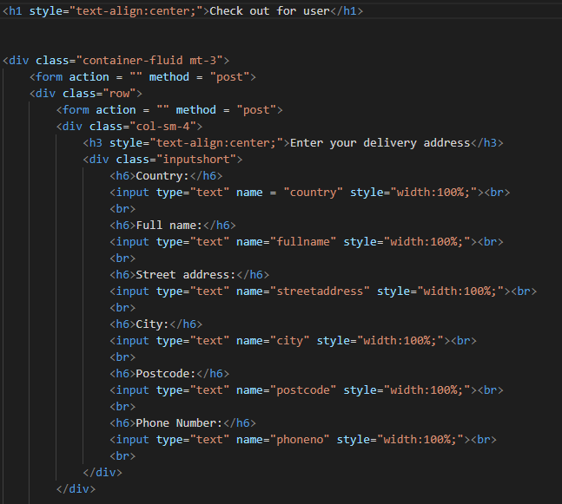

The second section is pretty similar to the first section

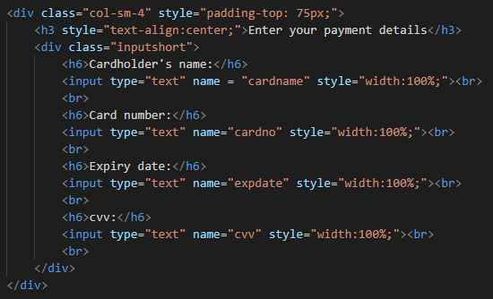

However for the last section I have created an extra column grid for the total and the price. This is so that I can split all the details separately so if I want to include tax payment I can write what it is on the left and put the price on the right.

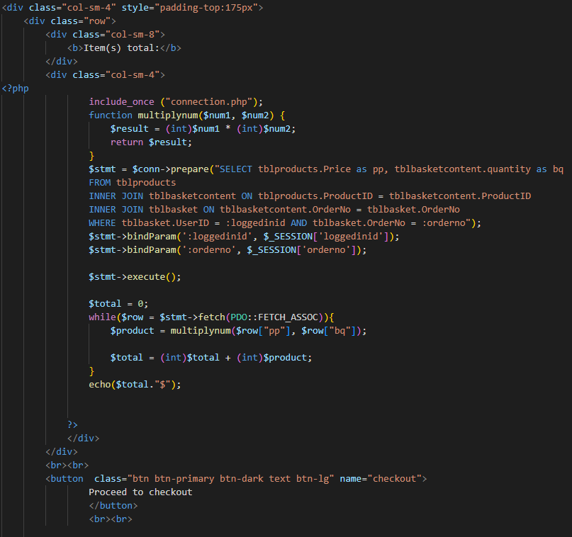

The overall view of the page then looks like this

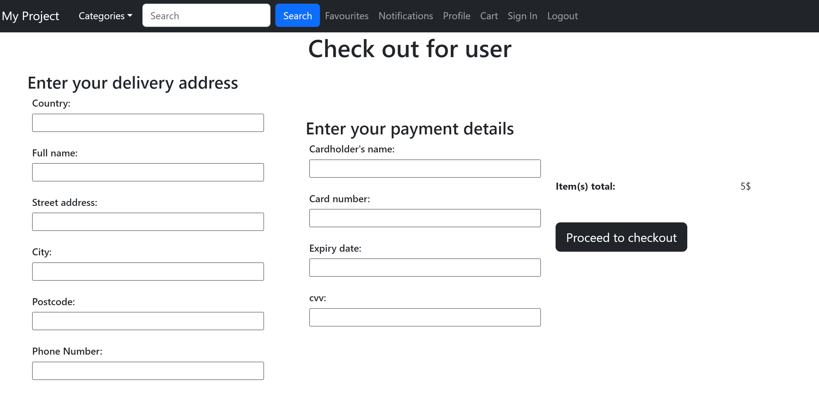

**Algorithms for checkout**

I will need to change the value in the table showing that the customer has paid using:

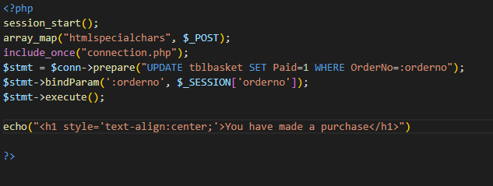

### Users category page

It will start off with the same navigation bar as above.

#### Initial Page Design





Aside from the navigation bar, I plan to organise the category pages so that all categories will have a similar webpage, just with a different description. I will keep it as brief and simple as possible to allow users to easily navigate through the webpages. For now I have used the old pictures which I will then change it later. These pictures allows you to click on them to send you to its own individual web page.

The result produces the following web page:



The button “show less” will be altered to allow users to view more items than the current one and extend the list of items in category.

#### Second draft

My second draft uses the idea that all the images are stored in a table, and I want to take the images from a folder and use that in formation to output it as follows for each image appropriately, this is done so using the code: what this does is it takes the sql statement and selcts all the data where the product id is 3 in which the category will be a keychain category. This then displays the image from the folder images and display it in an img tag



Overall I have altered all the image tags in the above images to this code so that it is all using the data from the table, and not just a random image I have inputted into the folder.

#### Third draft

For my third draft I had to change the php code entirely. I made the php code into a loop that echoes each row and each item one by one so that it will increment depending on how many is in the table this code is done:



What this does is it will use the sql statement initially to get all the information from the table where the catrgory is called keychain

Then it will run through a while loop when theres data being taken out and run through the code

I echo the initial code to create a row and a link then I echo the image itself where the image name will be taken from the table and then finished with a close. Every 4 images I will create a new row. This is done using a count and if statement. Once the count has passed 4 counts it will close div the row and then create a new row div

However for the actual image format my images seemed unaligned and not following a set form. This is changed by setting a class in the img tag to create a set image format for all images



This will then produce the following format:

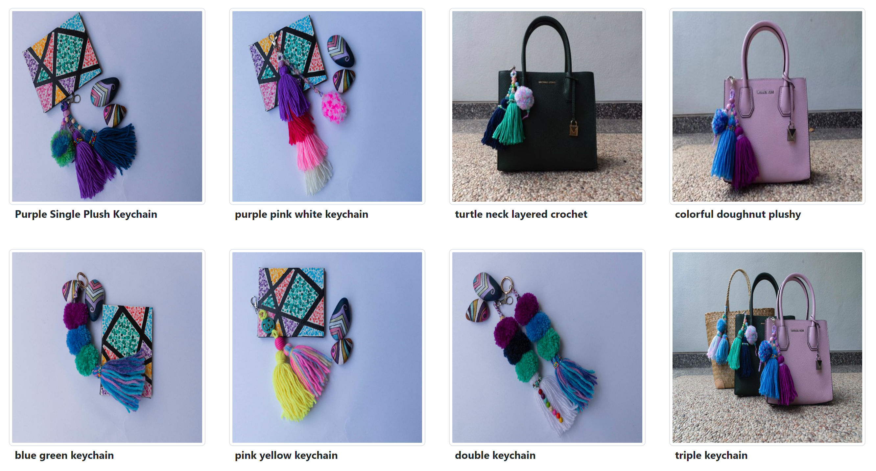

### Product Page

#### Draft 1 template

In order to split up the pages to 2 separate grids to organise all the detail about products, I have used bootstrap to apply 2 columns to the page using:





This is then evolved into writing up each side of the page.

Starting with the right side of the page for details about product

**Section 1**

In order to create a functional website in which users are able to view multiple pictures of the product, I will add a carousel under section 1 in which users are able to view the product they wish to purchase

For now I have created a picture from the table and used a review list to output all the reviews from the product

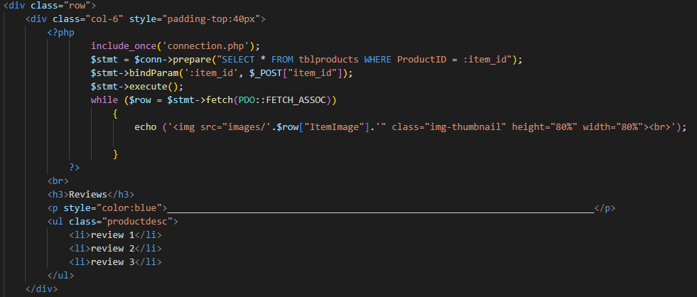

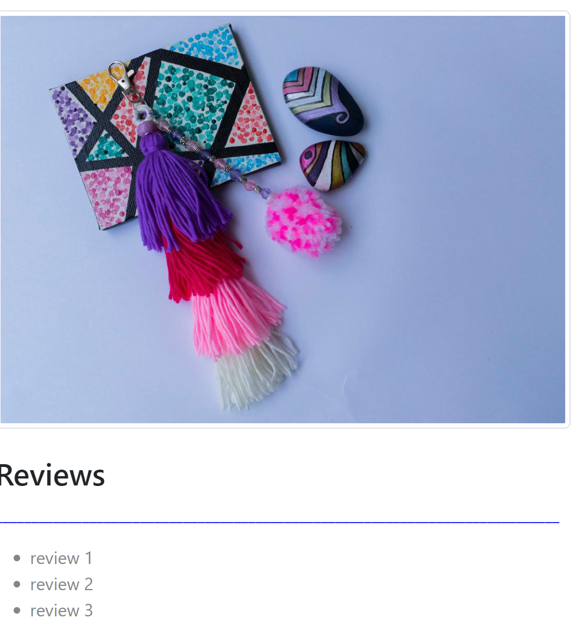

**Section 2**

In order to display information, I have used php to output the information in regards to the information in the table stored in sql. For outputting the product name as well as a brief description about the categories:



The 5th line from the top uses sql to select the name of the product from the table “tblproducts” in which the product ID is ID number 1. This is then outputted by echoing the data into the webpage

For the category description by echoing data under “” it outputs the words as a print algorithm.

For description I have used a container to put all the information in a box in which the description of the product will be in. this is done so using



The initial div creates a container while the second class under the p tag just changed the color of the text in accordance with the stylesheet

This will then output the following information for one of our test products.



At the bottom of this webpage I will include a function to add to the cart and to buy now.

Each of which will have its own webpage to perform a functionality



In order to add a drop down box for the quantity as well as to store the value of the drop down. I have used this code:



The outcome this creates looks like this:

#### Draft 2

Section 1 is kept the same as it just simply takes the images from the folder. The only change is that I use the itemid from the form before as a bind parameter as the productid instead of specifying the productid in advance.

For the second section which I changed, I have completely altered the code to make it shorter, faster, more efficienct and suited to tis purpose:



What this code does is it will take the item id from the form before as the bind parameter and select all the information where the product id is from that bind parameter.

Then while theres data being taken out, I use an echo function to create a html tag to display information in a container format. This is then finished with rows using the data from table

This however produces an error where all of my forms create the same product id of 6 and it doesn’t change with each image. This is caused by the transfer of item id from the bind param as the value being transmitted is just the same value. For example clicking on picture 2 outputs the following data on my individual pictures webpage:



This is caused because my form tag was outside of everything meaning it was taking all 7 products in 1 form so it will only show the last value being inputted. This is fixed by changing the form tag into each product itself so that each product will create a different form.



### Add to cart

In order to add to cart, this will get very confusing. I will have to use the value of the product ID from the webpage and send that value towards another page where it will store the data.

The idea is that under a specific order number generated with the same user, I will assign the product ID to the order number under tblbasket content. The way for this to work is under the same user ID and order Number, each webpage for the product wil consist of a value, which will be the product ID and store it into the table.

This is done so using the following code:



What this currently does is stores the product id and its quantity into the table. I will need to fix the order number as it currently only shows the value 1. This value 1 will have to change depending on the order the person currently has.

This successfully shows on the table on xampp.



The second part of the add to cart function is to do with my tblbasket page, this is where I have to store formats such as dates



I will need to find the current date of adding to basket, and the date which is 2 weeks from that date itself.

My first attempt was using this code:



This uses the function datetime which gets the current date on the system and I modify it by adding one month to it so just changing the month value. However this produces an error:



This is because my date function didn’t work as the date got modified and wasn’t in the format of

y-m-d

This is then fixed using this code:



Using orderno 1 as a template and 0,0 to show that it hasn’t been delivered or paid yet

This however doesn’t work because for one there is a duplicate in data the primary key and also it doest create a new orderno for each one.

What I will try to do now is instead of doing the orderno here, I will create the new order for every time I login as a user, then use a session variable to send that orderno number to the other file when needed. I will start this by putting the orderno in the **loginprocess page** while sending a variable as a session variable too. In my first attempt, this was the code:

The idea in my mind is that I will create an order for each user that logs in to the website, and use that order number in a session variable to be transported so that in the basket add page I will use that session variable to place it in the correct order no



This however doesn’t work because



This is caused by numerous problems such as the idea that orderno was not being fetched, and other problems which arised. I fixed this by using this code:



What this does is that after inserting all the data into the table, I take the last value (max) that was inputted into the table and takes a session variable for that order number. And this fixes the problem.

I musnt forget to add this into the **basket add page**:this takes in the session variable orderno from the login page

### Sign in Page

I will separate the sign in and sign out page as it has 2 different tasks

#### Initial page design

In my initial design I produced a template and rough idea for where all of the buttons will go as well as some brief buttons in order to send data



This code produces the following web page which is a rough layout with no colors



This however creates an error when I try to input data into the table:



This was caused because my variables in the previous page did not match the data in the process page

In order to create a textbox covering the whole page, I will use a css style sheet to put all of the style boxes. For input boxes I will use:



#### Second page draft

After editing the webpage to design it more aesthetically and add key features, this produced:



To arrange the boxes to fill the whole page, I have used the following code:



**Algorithms for log in pages:**

I have used a code in order to get the hashed password from the table, unhash it using the same algorithm and check if the email with the same email and password is correct where the type is a user:



This then produces another error in which:



This is caused because I have to “WHERE” SQL scripts in my SQL statement in which it isn’t possible to work with. To solve this problem, I have changed it from another WHERE to an “AND” cause.



This still produces another error which is that when I input a wrong account it doesn’t go back to the login.php page. This is because of the while loop and that if the passwords don’t even match, it wont go through the while loop so it doesn’t even access the header. This is dealt with:

I first set the backurl in the beginning, and if all the passwords match, it will go through and change the backurl



### Sign Up

In junction with this page, the “create an account” page will lead you to a different page where you can sign up users and add them to the database so that they have their own account. This is done so through this code

#### Initial idea

In order to create an initial template for the form (inputs from user to create an account), I made a simple form with a submit button in order to input the data from users.



In order to register users, I will need to link the values given from the form to variables in my table. This is done so using the php code:



This code inputs all the data into my table. It will bind certain variables with data from the previous page and then input it into the table through the necessary columns

### Log Out

In order to let users log out of their account and sign into another one. We will add a page in order to allow users to unset their binds using:



An additional function I will add in the logout pages is to delete an order if the user hasn’t made any orders in the table. This is to help remove waste and uncalled variables because they will have a row in their table with no data added into it which just wastes space. This is done so using:

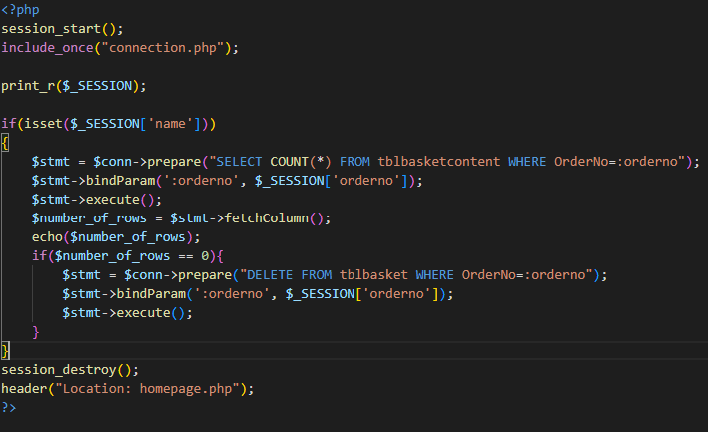

## Admin pages

### Main page

In order to organise all the admin functions appropriately I will create a very simple draft template using a navigation bar and colour scheme



Through the usage of the same colour scheme as the main website, I create a very brief and draft admin portal page. This just will have functions which an admin will have. For now I have added storing products and adding users but added extra boxes incase there are additional functions for admins that will come in handy.

There is also a function to go back to the users page

This code is used by:



What this does is that it creates a session to bring to the loginadmin process and will only be allowed in if the session admin is created. Then theres a navbar using bootstrap 5. Then the next is creating the buttons using a grid function



### Security

In order to ensure that only admins are allowed to use this site through their specified logins, we will create a login page simply for admins and no one else. To access it they will be immediately brought to a new login page to check their access.

This brings you to this web page:



Similarly using the same code as the loginprocess page. We create a loginadminprocess page using similar code:



Then at the top of our web page for the admin portal main page, we create a session variable in order for users to having to automatically be brought to the sign up page before accessing anything



However this produces an error as it doesn’t go through the while loop and isn’t registering the fact that the password and email is correct.

This was caused by the fact that when I creates a session start variable, it is checking whether email has been set in a session variable and in loginsadminprocess I didn’t set any session variables called email.

This is fixed by:



What this does is it checks whether there is a session called admin and in my loginadminprcoess code I create a session variable called admin with a random variable of admin in it.

### Adding users

Similarly to the create an account page in the users portal, for admins the only additional feature is that you can assign a role and let them be an admin or a user. The code is the same and as for the assigning of a role it uses :



Then this gets linked to the webpage where all the php code is used and is used as follows



### Adding products

In order to add products I initially added a draft form to input information and store them in my table. I have used a function to add an image from our file, store the image inside the table and sort it into a folder under the pages called “images”. This is done so using



However I had come across an error which states that:



This is due to not having a key bit in my normal forms page in which the actual array for storing my image didn’t go through



This code allows me to store images into a format which is saved in a table, and stores these images in a file called images.

Simply for the purpose of the web based project I will use css to decorate it and it loks like this now:

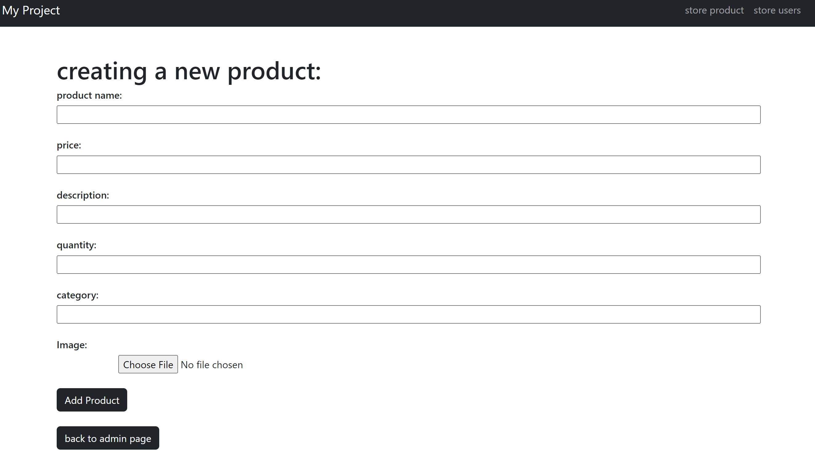

Checklist on what to do:

* checkout page